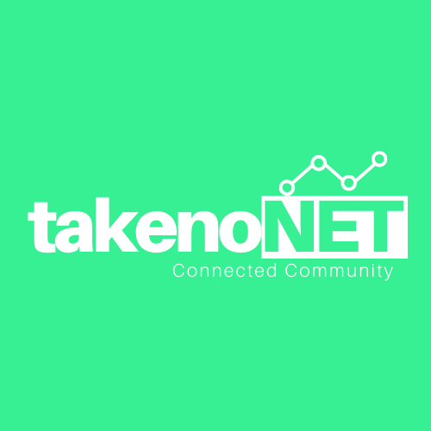

**Community Wireless Network**

**Connecting the world to the Community**

Access to the internet is necessary for today’s society. Activities like shopping, applying for jobs, and continuing education are increasingly moving from the physical realm to the web.

takenoLAB believes that internet and connectivity are vital for everybody and nobody should be left out. We have been providing digital skills training since 2015, transforming the potential of young people to engage with the modern digital economy. We are expanding our impact to train youth across the camp and surrounding villages, but our new initiative aims to transform access as well as skills.

The Dzaleka Refugee Camp has been left on the wrong side of the digital divide, with poor connectivity stifling people’s potential to learn, transact and engage with the world, building careers and identities online. takenoNET is how takenoLAB will change this by bringing high quality, affordable, sustainable internet access to the area.

**The main challenges:**

1. Digital divide: Refugees suffer lack of access, with limited availability of information and opportunities
2. Poor connectivity prevents the use of online technologies and solutions by or to benefit the community
3. Expensive internet access cost: Because of the nature of different Internet service providing companies, prices of the internet are very high which limit the big number of community member in using connectivity.
4. The dominant business models among internet service providers lead to a lack of innovative ideas around connectivity, and limited motivation to extend digital access, keeping the community poor and dependent
5. Poor involvement of community members in establishing a network, and making sure it is responding to community need and creating community benefit

**Proposed solution:**

1. To establish a community network, which will tackle the above-mentioned challenges
2. High-speed internet
3. Affordable and accessible network
4. Education and empowerment
5. Involve a diverse volunteer community, developing technical knowledge and skills in the community
6. Democratizing the internet

takenoNET will offer a new approach to connecting low and moderate-income communities to the Internet. The goal is to reach people who have never had internet access or experienced the possibilities that good internet brings. takenoLAB believes this project will open other new doors for underprivileged communities in Malawi.

This network will offer communities opportunities to stay connected with their relatives and improve access to emergency services. takenoLAB believes that this project will offer an innovative, effective strategy for connecting people not just to the web, but also to their neighbors and their community.

**Background**:

TakenoLAB is in the perfect position to implement this project based on the impact it is creating in the community of Refugees and rural communities (marginalized communities). TakenoLAB as a Tech Hub and ICT academy produces hundreds of competent and skilled young people every year that can create a range of solutions in Dzaleka and for the world. These young minds still face connectivity challenges, preventing them from expressing their potential through online work, internet-based solution development, and the like.

Due to takenoLAB’s background in technology and business entrepreneurship, and advisory support from one of Malawi’s most dynamic internet service providers, takenoNET will be able to provide internet access that is affordable, ubiquitous, and democratically controlled. takenoNET will offer an exciting new tool for community economic development that will reduce poverty, promote a sense of community, and encourage civic participation.

**Strategy for Success**:

* Provision of technical team from takenoLAB
* Build and managed by the community
* Partnering with different Internet service providers to provide the best and cheap services to the community

**Potential Partners**

* Converged Technology Network (CTN) – A Wireless Internet Service Provider based in Lilongwe (Discussion in progress)
* TNM
* Community members (10 members joined already)

**Contact Person:**

* Remy Gakwaya – Founder and CEO at takenoLAB – Expert in software development and developed passion for Community Wireless Network Connectivity

Budget

|  |  |  |  |  |
| --- | --- | --- | --- | --- |
| Item | Description | quantity | Cost | Total |
| Central Unity AP | Main Center For Distribution of Wireless Network | 1 | $1000 | $1000 |
| Network Repeaters | AP repeater points | 10 | $300 | $3000 |
| Backbone Internet | Internet Services that will be connected to takenoNET | 24 Months | $350 | $8400 |
| Management cost | * Management team * Technicians | 24 Months | $1200 | $28800 |
| Backup System | Solar system for each Acess Point Repeater – using sustainable energy to minimize network downtime | 10 | 240 | $2400 |
| Total | | | | $43600 |

**Conclusion**

TakenoNET provides an opportunity to connect 1000 people, many of whom are currently digitally disenfranchised and transform their access to services and opportunities online. Projections show it to be profit-making within a year, meaning the community benefits created can be sustained over the longer term without further funding support. The innovative approach may also provide a model for sustainable community access in digitally excluded areas within the country.